

**Problem Solvers Center**

Submitted to the

Department of Master of Computer Applications

in partial fulfilment of the requirements

for the Mini Project (MCAP1)

**by**

**Shravan K.S - 1MS21MC051**

**Shreyans Saklecha - 1MS21MC052**

**Under the guidance of**

**Dr. Manish Kumar**

**Department of Master of Computer Applications**

**RAMAIAH INSTITUTE OF TECHNOLOGY**

(Autonomous Institute, Affiliated to VTU)

Accredited by National Board of Accreditation & NAAC with ‘A+’ Grade

MSR Nagar, MSRIT Post, Bangalore-560054

[www.msrit.edu](http://www.msrit.edu)

**2023**



**DEPARTMENT OF MASTER OF COMPUTER APPLICATIONS**

**CERTIFICATE**

This is to certify that the project entitled Problem solvers’s center is carried out by Shravan K S bearing USN 1MS21MC051 and Shreyans Saklecha bearing USN 1MS21MC052 students of 3rd semester, in partial fulfillment for the Mini Project (MCAP1), during the academic year 2022-2023.

**Guide Head of the Department**

**Dr. Manish** **Kumar**

**Name of Examiners Signature with Date**

**ACKNOWLEDGEMENTS**

I would like to express our gratitude to everyone who helped and supported me during this project. Special mention to our guide, Dr. Manish Kumar for his consistent support and timely advice that has helped us tremendously while developing this project.

We would also like to thank other peers who helped us gather materials and references which helped us tremendously for completing the project.

**DECLARATION**

I hereby declare that the project report entitled “ Problem Solver’s Center ” based on study undertaken by me, towards the partial fulfilment for the Mini Project (MCAP1) carried out during the 3rd semester, has been compiled purely from the academic point of view and is, therefore, presented in a true and sincere academic spirit. Contents of this report are based on my original study and findings in relation there to are neither copied nor manipulated from other reports or similar documents, either in part or in full, and it has not been submitted earlier to any University/College/Academic institution for the award of any Degree/Diploma/Fellowship or similar titles or prizes and that the work has not been published in any specific or popular magazines.

**Place: Bangalore Shravan k Subrahmanya**

**Date: 1MS21MC051**

**Shreyans Saklecha**

**1MS21MC052**

**ABSTRACT**

The Problem Solving Center is an online platform that aims to provide a community-driven approach to solving problems. The platform is designed to be similar to popular Q&A website like Idea Connect, but with a focus on solving real-world problems.Users can ask questions related to various fields such as technology, finance, health, and education, and other users can provide answers and solutions to these questions. The platform also allows users to upvote or downvote answers, making it easy to identify the most useful solutions.The Problem Solving Center is built with the aim of creating a comprehensive knowledge base for solving problems. It allows users to search for previous questions and solutions related to their problems, reducing the need for redundant questions. The platform also includes features like tags and categories to help organize questions and make it easier to find relevant information. Overall, the Problem Solving Center is designed to be a collaborative platform for solving real-world problems. It leverages the collective knowledge of the community to provide solutions that are not only effective but also backed by real-world experience.

**Table of Contents**

1. Introduction 1

1.1 Overview 1

1.2 Problem Definition 2

2. Literature Survey 3

3. Hardware and Software Requirements 5

3.1 Hardware Requirements 5

3.2 Software Requirements 5

4. Software Requirements Specification 6

4.1 System Features 6

4.1.1 System Feature 1 7

5. System Design Description (SDD) 8

5.1 System Overview 8

5.2 Database Design/Data Set Description 9

5.3 Functional Design 11

5.3.1 Describe the functionalities of the system: 15

5.3.2 Behavioral design: 16

6. Implementation 17

6.1 Source code 17

6.2 Test Cases 17

Description of Testing 17

7. Results and Discussion 18

8. Conclusion 19

9. Scope for Further Enhancement 20

10. Bibliography 21

# Introduction

## Overview

Problem solving is the act of defining a problem; determining the cause of the problem; identifying, prioritizing, and selecting alternatives for a solution and implementing a solution. But sometimes what happens is that individuals could not find a solution to a certain problem, then in that case they can contact some kind of organization that can be really helpful to solve their problem in minutes.

A problem-solution pattern divides information into two main sections, one that describes a problem and one that describes a solution. This pattern is typically used in persuasive writing, where the writer's general purpose is to convince the reader to support a certain course of action. The pattern is designed to compel the reader to make some kind of change in opinion or behaviour by establishing that a problem exists, then providing a solution. In the problem section, the writer identifies different aspects of the problem being discussed and offers evidence of these problems. In the solution section, the writer identifies a potential solution and supports the effectiveness of this solution over others.

For example, suppose a writer's stated purpose is to persuade his/her readers to ride bicycles as their primary form of transportation. First the writer will attempt to establish that common forms of motorized transportation create compelling problems that require a solution. Then he/she will show how the proposed solution - riding bikes - provides a beneficial alternative to driving.

## Problem Definition

The next step in problem solving is to formally define the problem to be addressed. This is a negotiation between the individuals tasked with solving the problem and the individuals who over-see their work. Essentially, the parties need to come to an agreement on what a solution to the problem will look like. Are the overseers anticipating an implementation plan, a fully operational production line, a recommendation for capital investment, or a new product design? What metrics are considered important-cycle time, material costs, market share, scrap rates, or warranty costs? Complex problems may be broken down into mutually exclusive and collectively exhaustive components, allowing each piece to be addressed separately. The negotiation should recognize that the scope of the problem that is defined will drive the resource requirements of the problem solvers. The more focused the problem definition, the fewer resources necessary to generate a solution. Finally, the time frame for problem analysis should also be established. Many business problems require an expedited or emergency response. This may mean that the problem solvers need to generate a temporary or interim solution to the problem before they can fully explore the underlying causes of the problem. Ensuring that the overseers recognize the limitations inherent in an interim solution serves to preserve the credibility of the problem solvers.

Why is problem solving important? Good problem-solving skills empower you not only in your personal life but are critical in your professional life. In the current fast-changing global economy, employers often identify everyday problem solving as crucial to the success of their organizations. For employees, problem solving can be used to develop practical and creative solutions, and to show independence and initiative to employers.

# Literature Survey

**1.Effect of Problem Solving Support and Cognitive Styles on Idea Generation: Implications for Technology-Enhanced Learning**

**Slavi Stoyanov and Paul Kirschner (Open University of the Netherlands)**

This study investigated the effect of two problem-solving techniques: (a) free-association with a direct reference to the problem, called shortly direct, and (b) free-association with a remote and postponed reference to the problem, called remote, on fluency and originality of ideas in solving ill-structured problems. The research design controlled for possible effects of cognitive style for problem-solving—adaptor versus innovator. The results showed that both groups significantly outscored a control group on fluency and originality. The remote group outperformed the direct and control groups on originality, but not on fluency. Innovators scored significantly better than adaptors in the control group on fluency, but not on originality.

**2.Creativity in problem solving: Uncovering the origin of new ideas**

**Carol R. Aldous School of Education, Flinders University carol.aldous @flinders.edu.au**

Innovation and enterprise depend for their success on the development of new ideas. But from where do new ideas come? How do they arise? Finding solutions to such questions is at the heart of creativity research and the solving of novel problems. Reflection, not only in cognitive processes but also in the non-cognitive ones used in solving novel mathematics problems, is uncovering a way in which the origins of new ideas occur. A study involving protocol analysis of five expert problem solvers identifies three critical elements. These elements have been employed to construct a framework of creative problem solving which may be used to foster creativity among young people under instruction and provide a cognitive explanation of the origin of new ideas.

**3.The role of problem solving ability on innovative behavior and opportunity recognition**

**Ji Young Kim, Dae Soo Choi, Chang-Soo Sung & Joo Y. Park**

The study adopts a quantitative research approach, using survey data from a sample of employees across various industries. The data is analyzed using statistical methods such as regression analysis to investigate the relationships between the variables. The results show a positive and significant relationship between problem-solving ability and innovative behavior, indicating that individuals with better problem-solving skills are more likely to exhibit innovative behavior. The study also finds a positive and significant relationship between problem-solving ability and opportunity recognition, indicating that individuals with better problem-solving skills are better able to recognize opportunities for innovation.

**4.PROBSOL: A Web-based Application to Develop Problem-solving Skills in Introductory Programming**

**Sohail I. Malik, Roy Mathew and Maytham M. Hammood,**

Problem-solving skills are considered as an important part of learning to program for novice programmers. Different techniques such as pseudocode and flowchart are used to develop these skills. In this study, a web-based appli-cation ‘PROBSOL’ was developed and offered to the novices in an introductory programming course to acquire problem-solving skills. The PROBSOL applica-tion is based on pseudo-code technique. One of the advantages of this applica-tion for novices is to focus on problem domain without worrying about the syn-tax of the programming language. Practice questions related to all the topics in-cluded in the introductory programming course were prepared and offered in the application. The results show a positive impact on the students’ learning outcomes and attrition rate. Students (treatment group) who used the PROBSOL application show better results compared to the control group.

# Hardware and Software Requirements

## Hardware Requirements

* Computer (4 GB RAM, Intel I3 Core Processor) for development of the application
* Processor 2.0 GHZ or above
* 150 GB Hard Disk Drive

## Software Requirements

* **Front end:**
  + HTML, CSS, JavaScript, Bootstrap
* **Back end:**
  + Django Framework, Python, Jquery

# Software Requirements Specification

## System Features

Sometimes, it is not enough to just cope with the problems – they need to be solved.Most people engage in problem solving every day. It occurs automatically for many of the small decisions that need to be made on a daily basis.

For example, when making a decision about whether to get up now or sleep in for an extra 10 minutes, the possible choices and the relative risks and benefits of obeying the alarm clock or sleeping later come automatically to mind.

Larger problems are addressed in a similar way. For example: “I have tasks that need to be done by the end of the week. How am I going to get them all done on time?”

After considering the possible strategies, 1 is chosen and implemented. If it proves to be ineffective, a different strategy is tried.

People who can define problems, consider options, make choices, and implement a plan have all the basic skills required for effective problem solving.

Sometimes following a step-by-step procedure for defining problems, generating solutions, and implementing solutions can make the process of problem solving seem less overwhelming.

Six step guides to help you solve problems-:

1. Identify and define the problem
2. Generate possible solutions
3. Evaluate alternatives
4. Decide on a solution
5. Implement the solution
6. Evaluate the outcome

### System Feature 1



# System Design Description (SDD)

## System Overview

**Fig 1 - Architecture Diagram**

## Database Design/Data Set Description

**Er Diagram:**

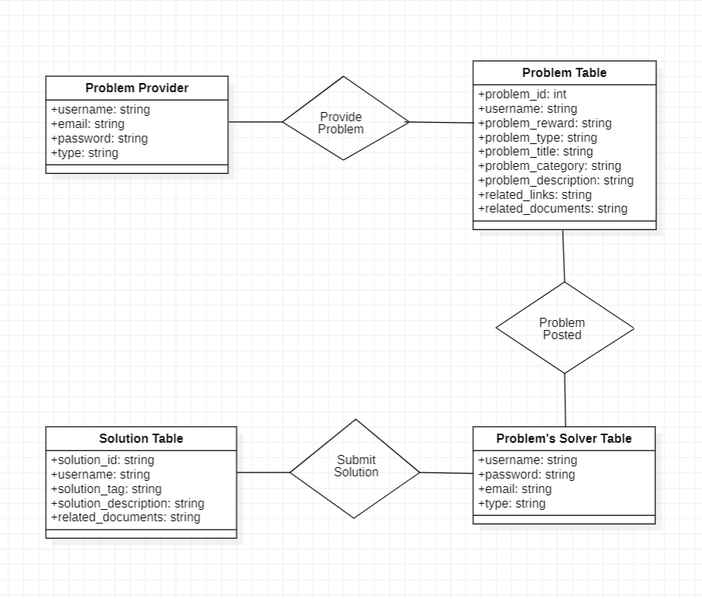

**Fig 2 - ER Diagram**

The entities in this diagram are:

1. Problem Providers: This entity represents the individuals or organizations who provide problems to be solved.
2. Problems: This entity represents the problems posted by the Problem Providers.
3. Solutions: This entity represents the solutions submitted by the Problem Solvers.
4. Problem Solver: This entity represents the individuals or organizations who solve the problems posted by the Problem Providers.

The relationships between these entities are:

1. One-to-many relationship between Problem Providers and Problems, as one Problem Provider can post multiple problems, but each problem is associated with only one Problem Provider.
2. One-to-many relationship between Problems and Solutions, as one Problem can have multiple solutions, but each solution is associated with only one Problem.
3. One-to-many relationship between Problem Solver and Solutions, as one Problem Solver can submit multiple solutions, but each solution is associated with only one Problem Solver.

**Table Structure** **:**

1). Problem Providers table:

CREATE TABLE Problem_Providers (

username VARCHAR(50) PRIMARY KEY,

email VARCHAR(255) NOT NULL,

password VARCHAR(255) NOT NULL,

type VARCHAR(20) NOT NULL

);

2). Problems table:

CREATE TABLE Problems (

problem_id INT PRIMARY KEY,

username VARCHAR(50) NOT NULL,

problem_reward INT NOT NULL,

problem_title VARCHAR(255) NOT NULL,

problem_type VARCHAR(20) NOT NULL,

problem_category VARCHAR(50) NOT NULL,

problem_brief_description TEXT NOT NULL,

problem_complete_description TEXT NOT NULL,

related_links TEXT NOT NULL,

related_documents VARCHAR(255) NOT NULL,

FOREIGN KEY (username) REFERENCES Problem_Providers (username)

);

3). Solutions Table:

CREATE TABLE Solutions (

solution_id INT PRIMARY KEY,

username VARCHAR(50) NOT NULL,

solution_tag VARCHAR(50) NOT NULL,

solution_brief_description TEXT NOT NULL,

related_documents VARCHAR(255) NOT NULL,

FOREIGN KEY (username) REFERENCES Problem_Solver (username)

);

4). Problems’s Solvers Table:

CREATE TABLE Problem_Solver (

username VARCHAR(50) PRIMARY KEY,

email VARCHAR(255) NOT NULL,

password VARCHAR(255) NOT NULL,

type VARCHAR(20) NOT NULL

);

## Functional Design

1. User registration - The user registration element is typically a critical part of a website's functional design. The fields you listed are commonly included in a user registration form:

1. username (Primary key): A unique identifier for the user, often used as their login name.
2. email: The user's email address, used for account management and communication.
3. password: A secure password for the user to log in to their account.
4. type: The type of user account, such as customer, administrator, or vendor. This field is used to determine the user's level of access to different parts of the website.

2. User details - These are additional details that can be associated with a user in a website's database.

1. username (Foreign key, Primary key): The unique identifier for the user, linked to their username in the user registration table.
2. user image: A profile picture for the user, often displayed on their account page.
3. First name: The user's first name.
4. Last name: The user's last name.
5. Personal brief information (Text area): A short description or personal statement written by the user.
6. Personal Identity Card type: The type of identity document the user has provided, such as a passport or driver's license.
7. Personal identity Card number: The number of the user's identity document, used for verification purposes.

3. Skills details - These fields can be used to store information about a user's skills in a website's database.

1. skill type: The general category of the skill, such as programming or design.
2. skill title: A specific name for the skill, such as "JavaScript Development" or "Graphic Design".
3. Skills brief details (Textarea): A short description of the skill, including the user's level of expertise and relevant experience.
4. certificate provider name (optional): The name of the organization that issued a certificate for the skill, if applicable.
5. skill document (pdf, certificate, etc) (optional): A digital copy of a certificate or other document that verifies the user's skill, such as a portfolio.
6. username (Foreign key, Primary key): The unique identifier for the user, linked to their username in the user registration table.

4. Project details - These fields can be used to store information about a user's projects in a website's database.

1. Project Title: A short, descriptive title for the project.
2. Project type: The category or type of project, such as web development or graphic design.
3. Project brief details: A brief description of the project's scope and objectives.
4. Project Complete details: A comprehensive description of the project, including the requirements, design, development, and delivery.
5. Related link: A URL or web address related to the project, such as a demo or portfolio site.
6. Related document: A digital file related to the project, such as a design file or presentation deck.
7. username (Foreign key, Primary key): The unique identifier for the user, linked to their username in the user registration table.

5. User reputation/grade/status model - These fields can be used to store information about a user's reputation or status as a solution provider in a website's database.

1. Number of membership for the solution provider’s company: The number of years or months the user has been a member of the company that provides solutions.
2. Number of solutions provided: The total number of solutions the user has provided on the website.
3. Number of solutions accepted: The number of solutions provided by the user that have been accepted by other users or clients.
4. username (Foreign key, Primary key): The unique identifier for the user, linked to their username in the user registration table.

6. User testimonials - this is for providing reviews by other Problem provider/Problem solver about other Problem provider/Problem solver.

1. fromUsername (Foreign key): The username of the user who is providing the review.
2. toUsername (Foreign key): The username of the user who is being reviewed.
3. Reviews / Comments / Feedbacks (Textarea): A written review or feedback provided by the reviewing user, detailing their experience working with the user being reviewed.

7. Problem Model (it is used to provide a problem by the problem provider) - This is a basic model for a problem submitted by a problem provider. The fields included in the model are:

1. Username (Foreign key of the problem provider): To identify the user who submitted the problem.
2. Problem Id (Primary key): A unique identifier for each problem submitted.
3. Problem reward (Money info): The amount of money offered as a reward for solving the problem.
4. Problem title: A short, descriptive title for the problem.
5. Problem type (Confidential, semi-confidential, public): The level of visibility and accessibility of the problem and its details.
6. Problem category: A classification of the problem based on its subject matter.
7. Problem brief description: A short summary of the problem.
8. Problem complete description: A detailed description of the problem and its requirements.
9. Related links: Any relevant external links related to the problem.
10. Related document (pdf, csv, excel): Any additional supporting documents related to the problem, such as data sets or specifications.

8. Solution Model - This is a basic model for a solution submitted by a problem solver. The fields included in the model are:

1. Username (Problem solver id): To identify the user who submitted the solution.
2. Solution id (Primary key): A unique identifier for each solution submitted.
3. Solution tag: A classification of the solution based on its subject matter or methodology.
4. Solution brief description: A short summary of the solution.
5. Related document (pdf, csv, excel, design etc): Any additional supporting documents or materials related to the solution, such as code, designs, or data sets.

9. Problem Provider registration (from here problem providers models will start) - This is a basic model for registering a problem provider. The fields included in the model are:

1. username (Primary key): A unique identifier for each problem provider, serving as the user's login name.
2. email: The email address of the problem provider, used for communication and account recovery.
3. password: A secure password for the problem provider's account.
4. type: The type of account held by the problem provider, such as a standard user, a premium user, or an administrator. This field may be used to determine the privileges or limitations of the user's account.

10. Problem providers details - This is a basic model for storing the details of a problem provider. The fields included in the model are:

1. username (Foreign key, Primary key): A unique identifier for each problem provider, linking to the username in the problem provider registration model.
2. Organization title/Name: The name or title of the organization associated with the problem provider.
3. Organization Category: A classification of the organization based on its industry, sector, or type of business.
4. Brief description about organization: A short summary of the organization's purpose, mission, or services.
5. Government License ID: A unique identifier assigned by a government agency to the organization, such as a tax ID or business registration number.
6. Government license document (License, Certificate): Any relevant licenses or certificates issued by a government agency to the organization, such as a business license or tax certificate.
7. Address: The physical address of the organization.
8. Pin Code: The postal code associated with the organization's address.
9. Contact number: A telephone number for contacting the organization.

### Describe the functionalities of the system:

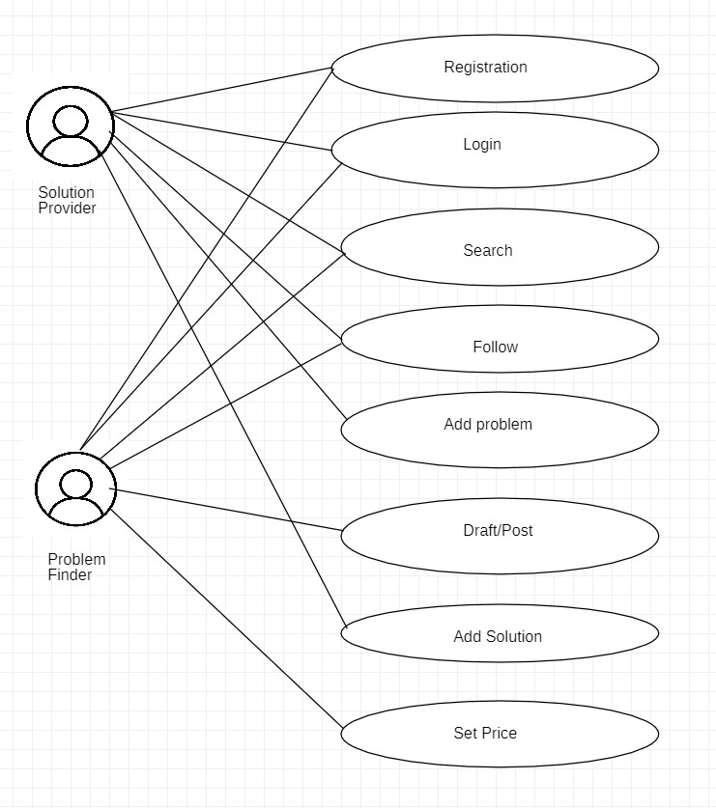

**Fig 3 - Use case Diagram**

### Behavioral design:

**Fig 4 - Activity Diagram**

# Implementation

## Source code:-

## Test Cases

## Description of Testing

**UNIT TESTING:**

Unit testing will be done after the development phase where the application will run over multiple defined use cases that aim to cover most of the functionality’s results validity and end point functioning. This will ensure error detection over multiple updates and will avoid any leaks.

**UAT:**

This is supposed to be done before final deployment since few pilot users will run and test the application against the identified use cases and make sure that the application is serving the purpose that it is supposed to.

# Results and Discussion

The result or conclusion of a Problem Solving Center will vary depending on the specific problem being addressed and the methods used to solve it. However, the overall goal of a Problem Solving Center is to help individuals or organizations find effective solutions to their problems and overcome challenges.

A successful outcome could include:

1. Improved understanding of the problem and its root causes
2. Development of a practical plan to address the problem
3. Improved skills and knowledge in problem-solving techniques
4. Increased confidence and independence in tackling future problems

Ultimately, the result or conclusion of a Problem Solving Center should be a more confident, capable, and effective individual or organization, equipped with the tools and strategies necessary to tackle challenges and achieve their goals.

**7.1 Screenshots :-**

1).Admin Page

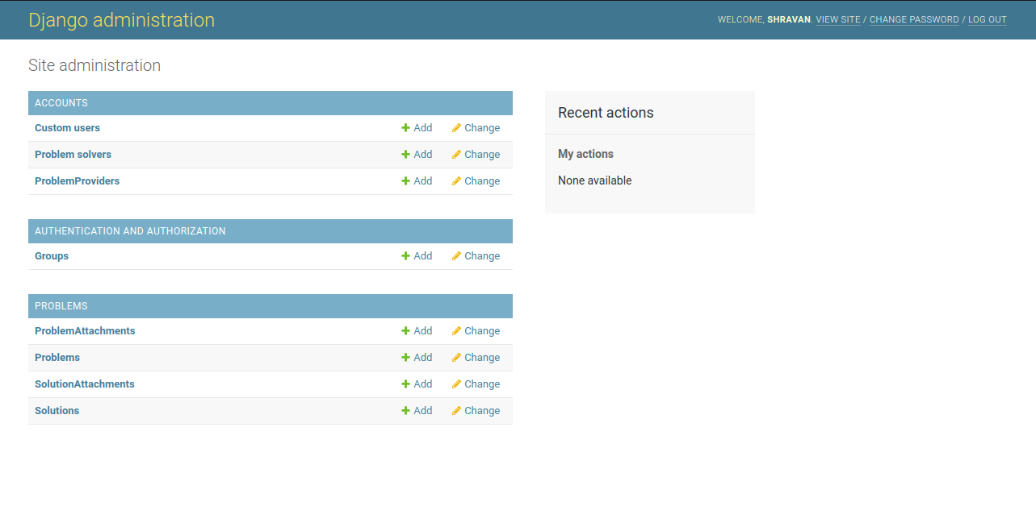

2).Drafts

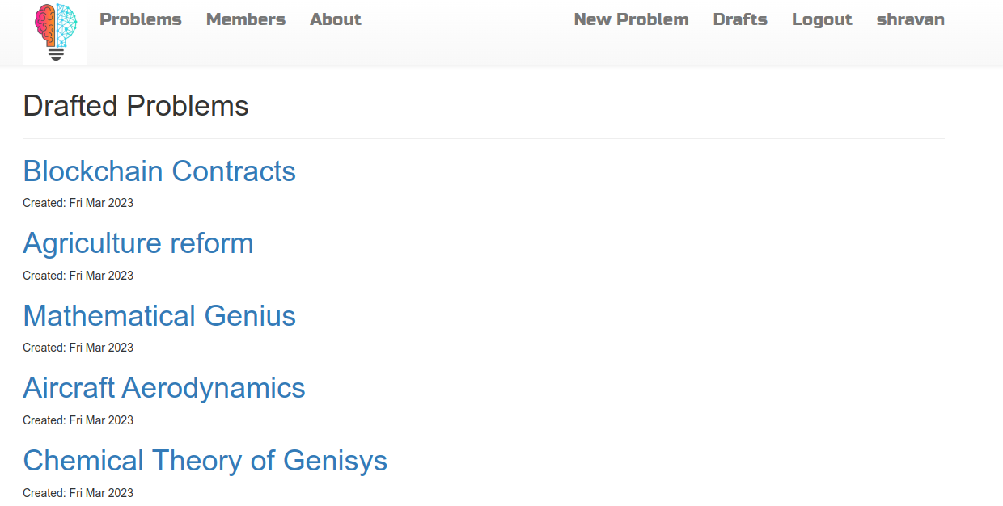

3).Form to add attachment to problem

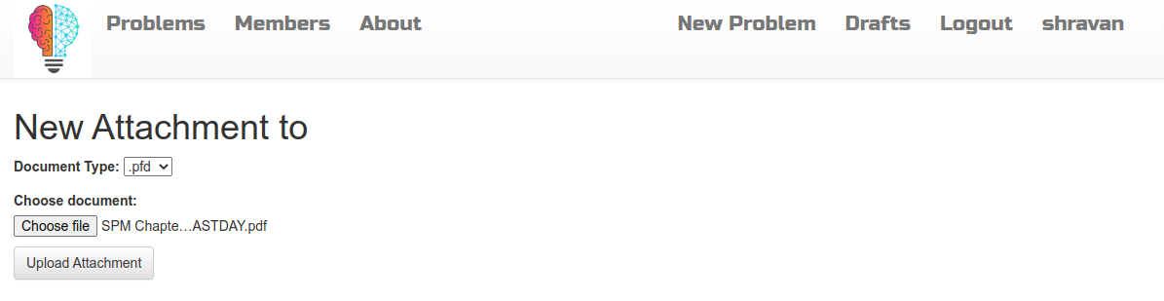

4).Home Page

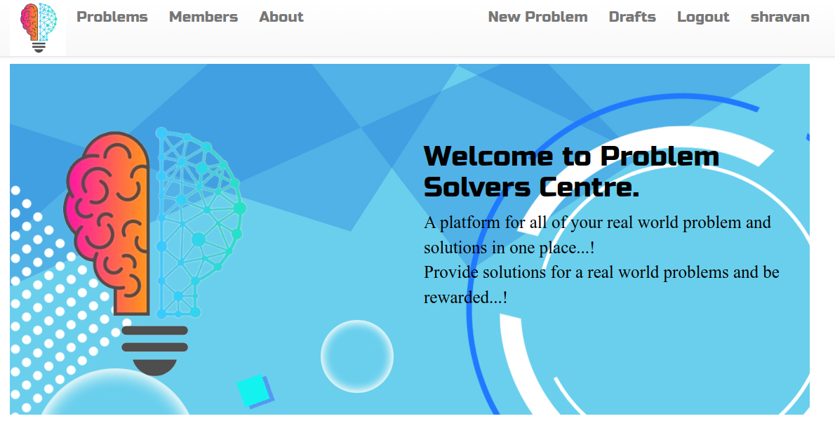

5).Login page

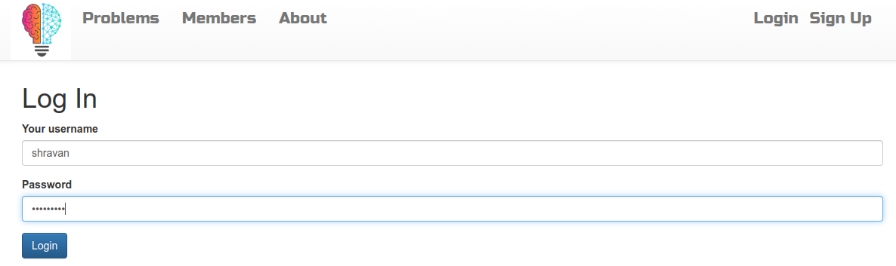

6).Members problems providers

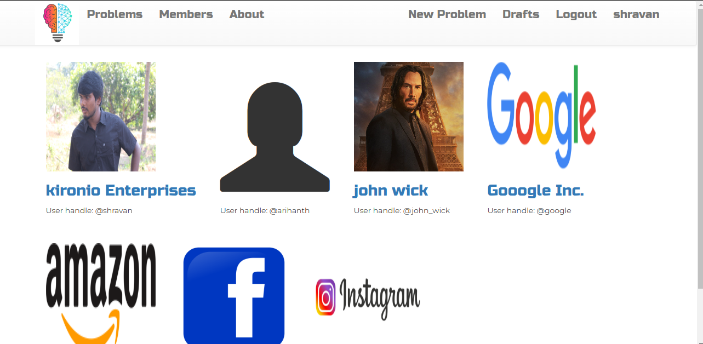

7).PP Problem Description

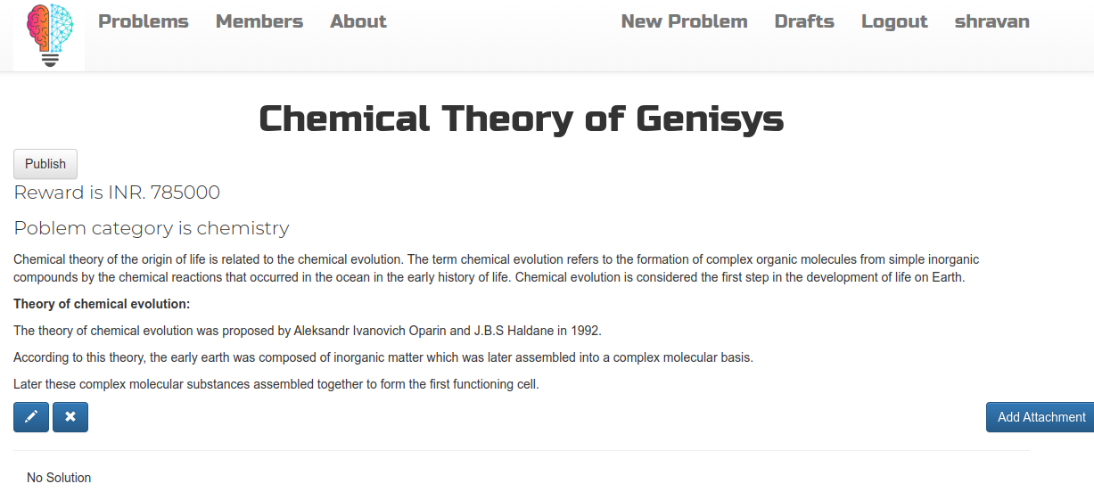

8).Problem reaction form

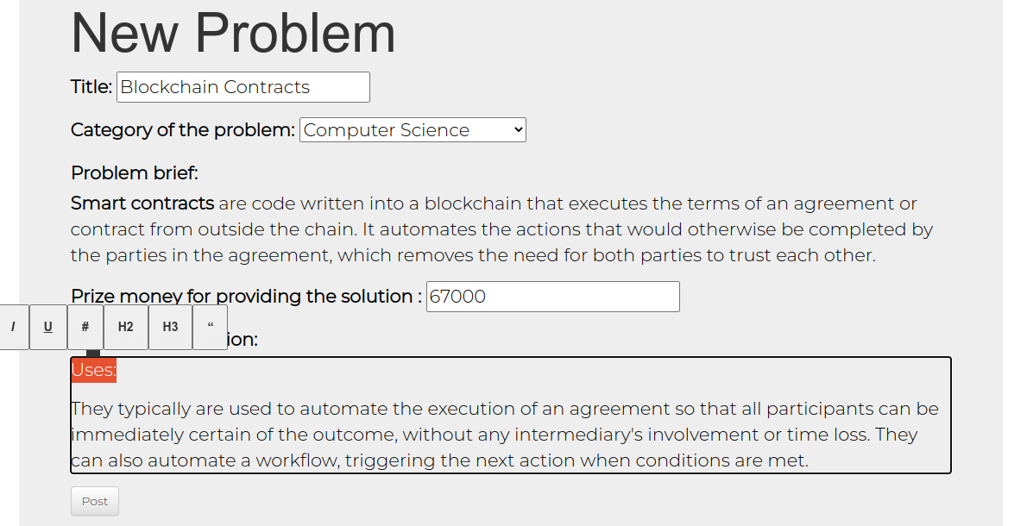

9).Problem Details Form

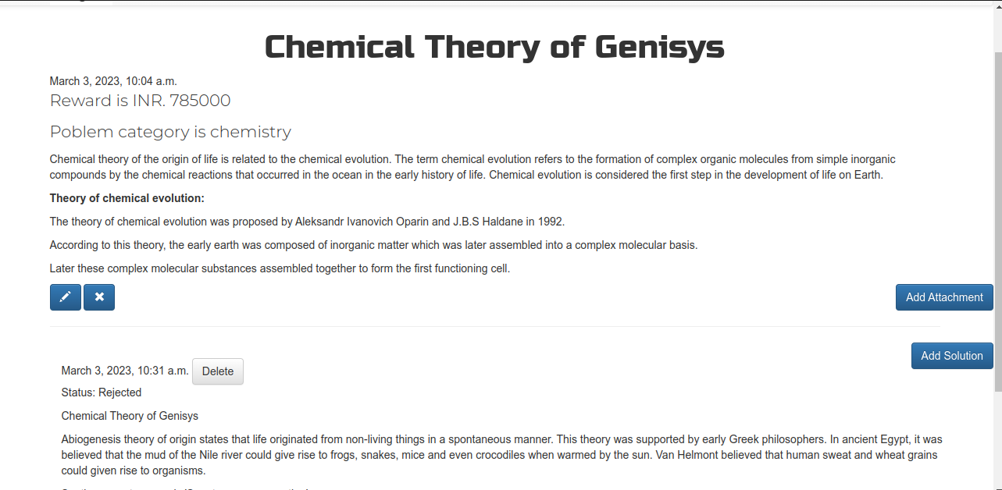

10).Problem Providers account edit form

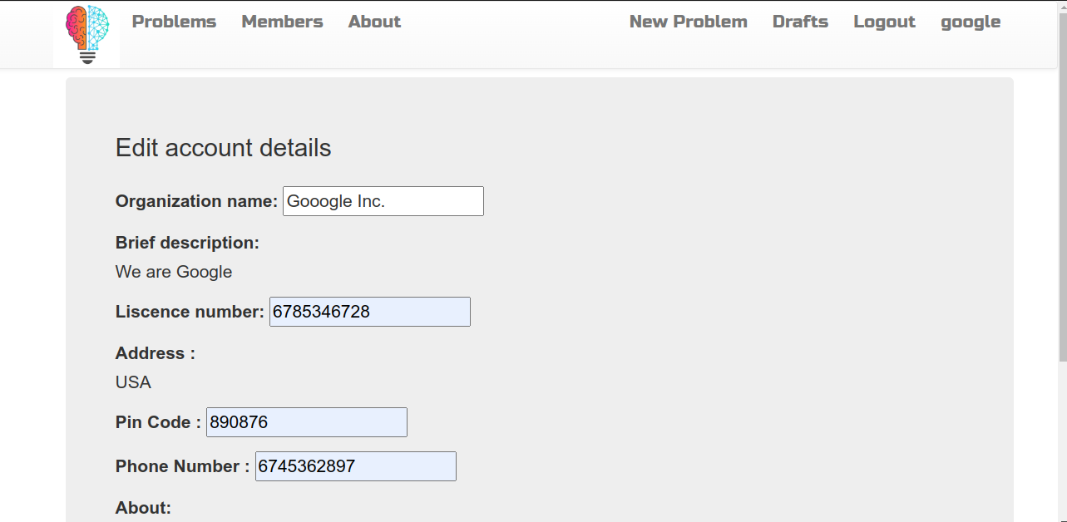

11).Problem List Page

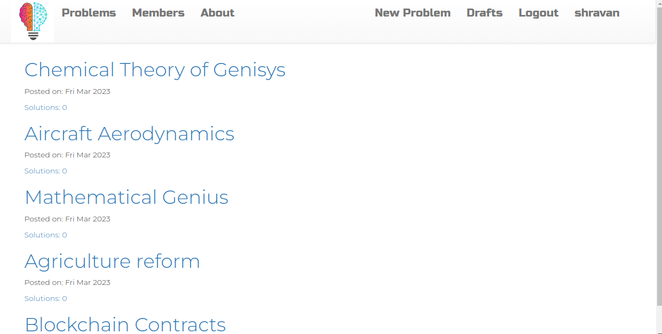

12). Problem Solvers account

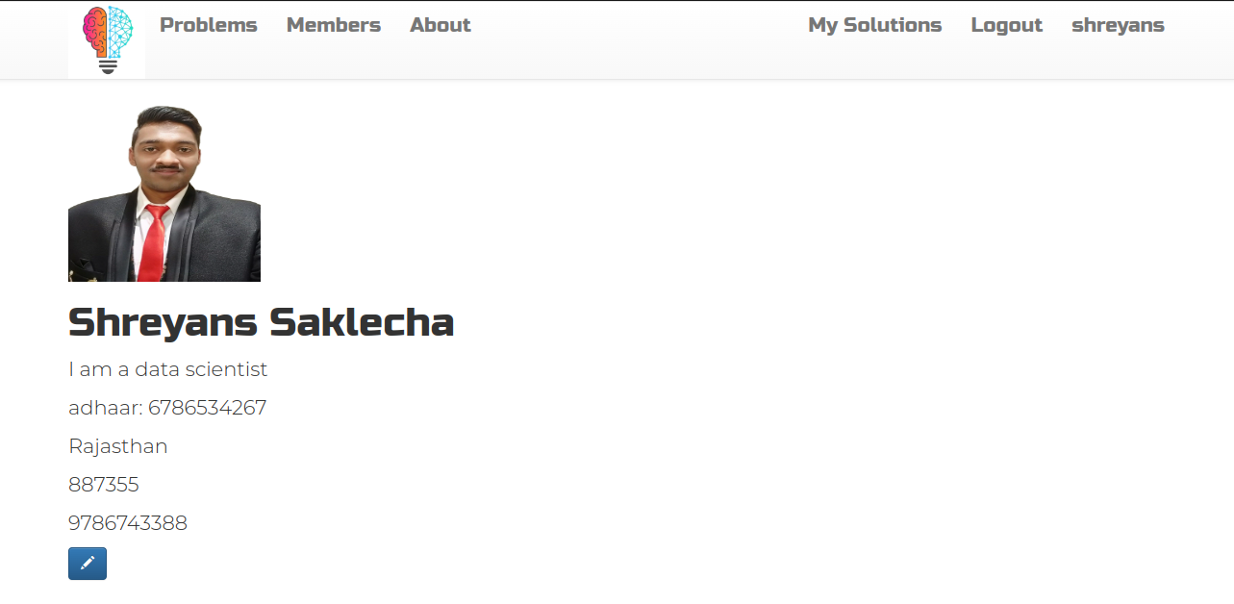

13).Problem solver form details

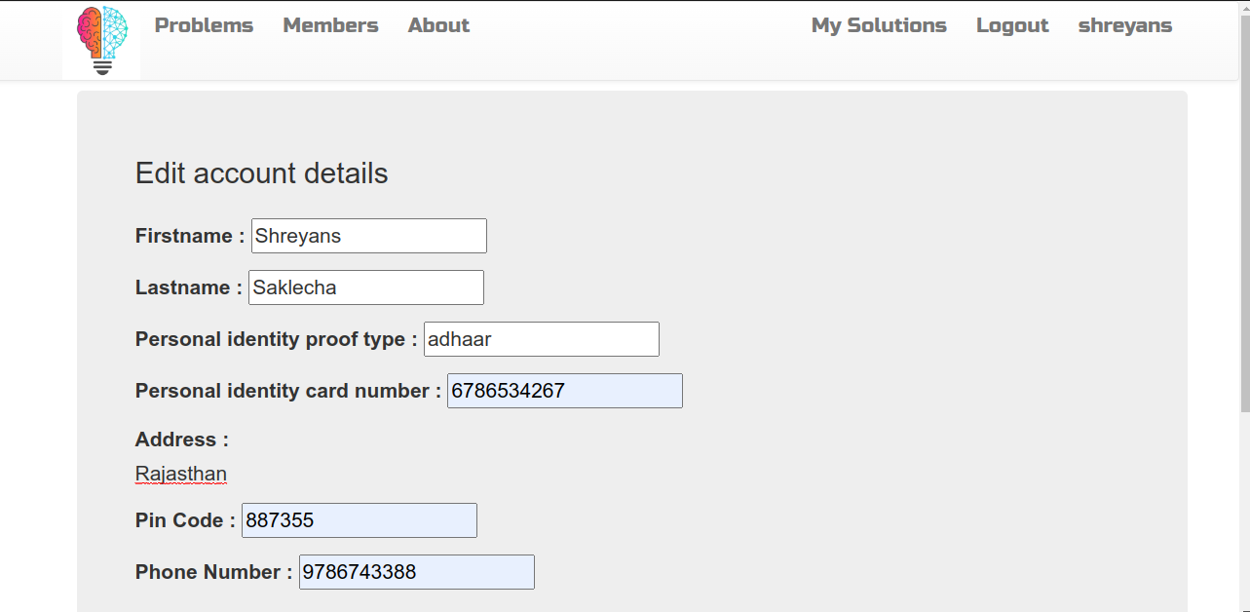

14).Problem solver's my solution page

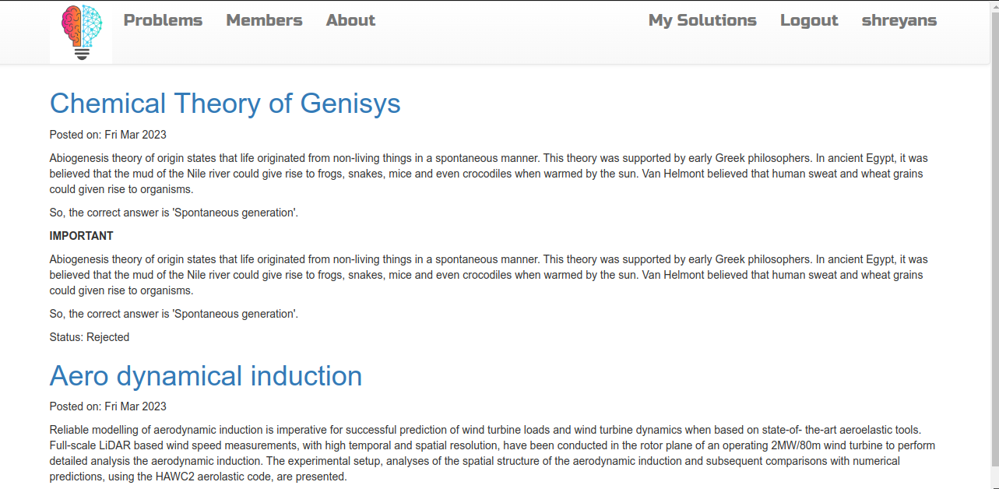

15).Sign Up

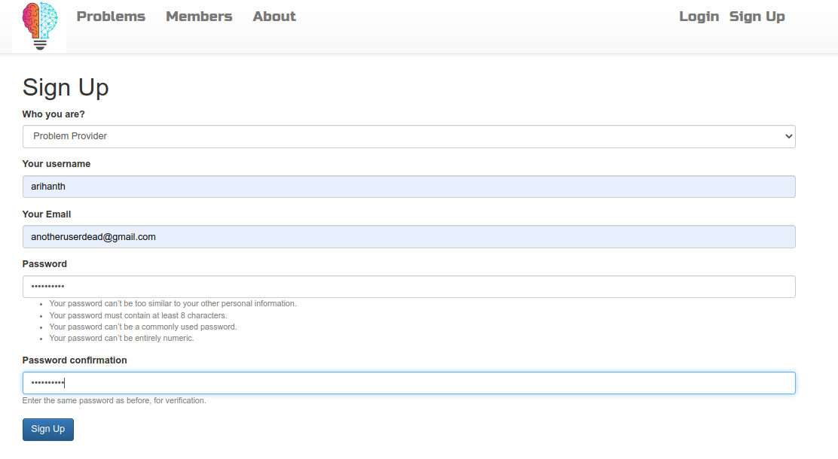

16).Solutions form

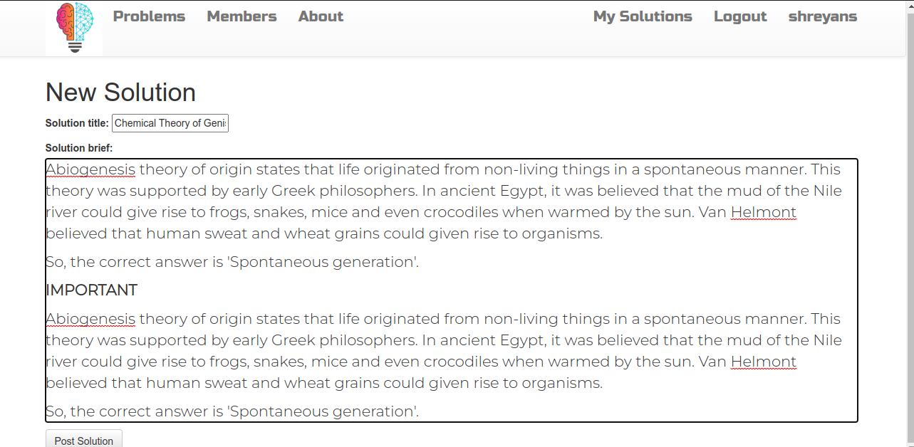

17).User account before entering details

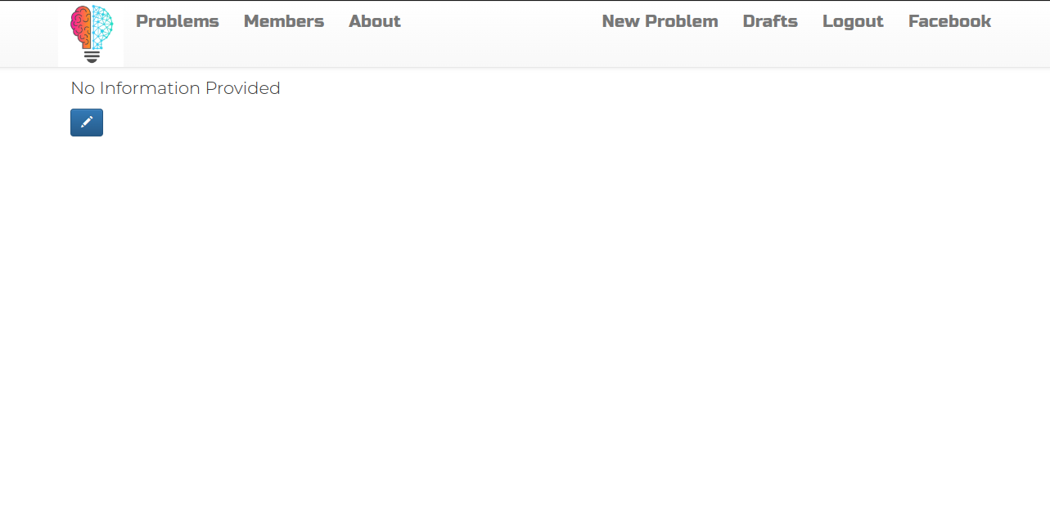

# Conclusion

Problem-solving applications provide a platform for users to seek answers to questions and share knowledge to find solutions to problems. These applications usually allow users to ask and answer questions related to specific topics, such as programming or general knowledge. Users can vote for answers that they find helpful, and those with the highest votes appear at the top of the list, making it easier for others to find a solution to a particular problem. Additionally, these applications provide a community-driven approach to problem-solving, where users can connect with experts and professionals to collaborate and solve problems together. Overall, problem-solving applications have become an essential tool for people seeking information and solutions to problems in their personal and professional lives.

# Scope for Further Enhancement

The scope of problem-solving applications is vast and growing, as more people turn to these platforms to find solutions to their problems. These applications have become an integral part of our daily lives, providing a platform for users to seek and share knowledge and collaborate with others to solve complex problems.

One major advantage of problem-solving applications is that they offer a community-driven approach to problem-solving. This means that users can connect with experts in their field and seek their advice and opinions on a particular issue. This type of collaboration can lead to more innovative and effective solutions to complex problems.

Another advantage of problem-solving applications is that they can be used by people from all walks of life. Whether it is a programmer looking for a solution to a coding problem, a student seeking information on a particular subject, or a business owner looking to solve a complex issue, problem-solving applications offer a wealth of knowledge and expertise that can be accessed by anyone.

As technology continues to advance, the scope of problem-solving applications is only going to increase. With the integration of artificial intelligence, machine learning, and natural language processing, these applications will become even more intelligent and efficient, making it easier for users to find solutions to their problems.

In conclusion, the scope of problem-solving applications is broad and diverse, with applications catering to a wide range of users and industries. These applications are becoming increasingly important in our daily lives, providing a platform for users to seek and share knowledge and collaborate with others to find solutions to complex problems.

# Bibliography

1. PROBSOL: A Web-based Application to Develop Problem-solving Skills in Introductory Programming Sohail I. Malik, Roy Mathew and Maytham M. Hammood,
2. Effect of Problem Solving Support and Cognitive Styles on Idea Generation: Implications for Technology-Enhanced Learning Slavi Stoyanov and Paul Kirschner (Open University of the Netherlands)
3. The role of problem solving ability on innovative behavior and opportunity recognition Ji Young Kim, Dae Soo Choi, Chang-Soo Sung & Joo Y. Park
4. Creativity in problem solving: Uncovering the origin of new ideas Carol R. Aldous School of Education, Flinders University carol.aldous @flinders.edu.au